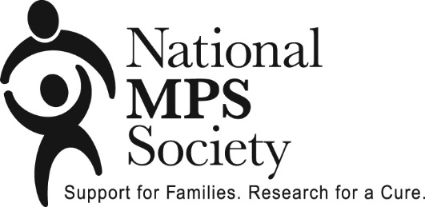

The National MPS Society has funded ten grants benefitting MPS IV (Morquio Syndrome) research in the amount of $870,000 during the nine year period of 2003-2015.

2003 - $60,000

Dr. Sharon Byers

Women’s and Children’s Hospital

North Adelaide, South Australia
“Inhibition of GAG Synthesis as a Therapy for MPS IVA and VI”

2005 - $100,000
Dr. Calogera Simonaro
Mt. Sinai School of Medicine
“Pathogenesis and Treatment of Bone and Joint Disease in the Mucopolysaccharidoses

2006 - $80,000
Shunji Tomatsu MD and Ph.D
Department of Pediatrics, Saint Louis University, Pediatric Research Institute
“Development of a Therapeutic Bone-Targeting System for MPS”

2007 - $100,000
Calogera Maria Simonaro, PhD
Genetics and Genomic Science
Mount Sinai School of Medicine
“Pathogenesis and Treatment of the Mucopolysaccharidoses

2008 - $60,000
Adriana M Montano, PhD
Saint Louis University
School of Medicine - Dept of Pediatrics
“Identification of genes for keratin sulfate biosynthesis: toward development of RNAi mediated therapy”

2009 - $80,000
Dr. Calogera Simonaro
Department of Genetics and Genomic Sciences Mount Sinai School of Medicine
“Novel anti-inflammatory therapies for the mucopolysaccharidoses.”
2010 - $60,000
Calogera M. Simonaro PhD
Mount Sinai School of Medicine
“A Novel Approach for the Growth & Expansion of Bone Marrow-Derived Mesenchymal Stem Cells in Mucopolysaccharidoses Type IV and Other Mucopolysaccharidoses”

2011 - $70,000
Adriana Montano
Department of Pediatrics, School of Medicine
St. Louis University
“Role of inflammation in pathogenesis of MPS IVA

2012 - $80,000
Shunji Tomatsu, MD, PhD
Nemours Children’s Clinic – Delaware Valley of the Nemours Foundation
“Development of Long Circulating Enzyme Replacement Therapy for MPS IVA.”

2013 - $60,000
Dr. Adriana Montano
Department of Pediatrics, School of Medicine
Saint Louis University
St. Louis, MO
AND
Dr. Raymond Wang
Children’s Hospital of Orange County
“Manifestations of Cardiovascular Disease in Morquio A: Evaluation, Assessment, and Therapy.”

